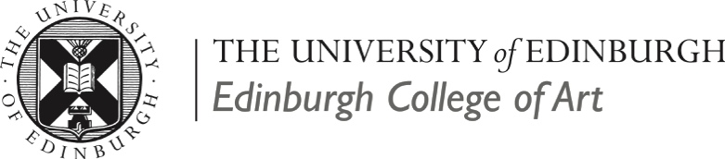
Exhibition Call out to graduates from the ECA Glass Department
Transition: ECA Alumni Glass Exhibition
16th -30th September 2016
Edinburgh College of Art (ECA), Sculpture Court, Lauriston Place, Edinburgh, EH3 9DF

An exhibition of the work of ECA Glass graduates, will be shown as part of a retrospective showcase of the ECA Glass department alongside a selection of historical artifacts, documents and archive pieces from the ECA Glass archive Collection. The show will run from the 16-30th September alongside the North Lands 20 Conference, which is being held at ECA on the 16-18th September. The Edinburgh College of Art Glass Department, within the School of Design is organising an open, juried exhibition of ECA glass graduates, the work will be represented as large format photographic prints. The exhibition will showcase the wealth of talent, which has emerged from the ECA Glass Department over the years. Glass has been established at ECA for over 100 years, the postgraduate course is unique within Scotland and located at one of the few centres of excellence in this discipline in the UK. Comprehensive college-wide workshops including a state of the art digital fabrication lab and specific hot and cold glass studio facilities enable our students to experience a programme in the conception and production of glass to the highest level. We benefit from visiting professional practitioners and lecturers, and students have the opportunity to participate in live projects and competitions. A digital catalogue will be produced to document and promote the exhibition.

Information for Applicants:

Eligibility
The exhibition is open to all ECA Glass graduates. Up to three images may be submitted for selection.

Deadline & Application
The deadline for submission to the exhibition is the 29th of July 2016. Applications should be submitted on the form below. Artists can submit up to three images of work for selection, if selected the images will be printed and mounted for use in the exhibition, no physical work will be required just high quality images.

Selection Criteria
The jury panel will be looking for excellent high quality images that expresses the transition in the artists work since graduation.

Selection
Selection will take place during August 2016, when a selection panel will meet to view the entries. The panel will consist of: Geoffrey Mann, Dr Jessamy Kelly & Dr Juliette MacDonald. All selected artists will be contacted by late August.
Correspondence
All enquiries/queries should be directed to: Dr Jessamy Kelly, Glass Department, Edinburgh College of Art, Lauriston Place, Edinburgh, EH3 9DF.
Email: jessamy.kelly@ed.ac.uk Telephone: 0131 6515 816
Submission
We will consider work in the medium of glass, or with the predominant use of glass. Artists should submit images of three images of work. Selection of the work will be by reference to the material supplied, so the quality of the visual images and documentation of work is very important. Additional information on the application form may be used for press and publicity purposes once exhibitors have been selected. Please check your images are submitted in the correct format. Digital images should be submitted in 72 dpi & 300 dpi and should be saved as JPEG files with your name, title, year made, size and photo credit. These titles should correspond with the form below.

‘Transition’ ECA Glass Alumni Exhibition

Submission Form

DEADLINE: 29th of July 20162016
Name | Tel
Address | Mobile
 | Fax
 | Email
Postcode | Website
Year(s) Studied at ECA: | Name of Department Head:
Date & Place of Birth: | Qualification(s) received at ECA:

Image | Title of Work | Dimensions (HxWxD) | Photo credit | Description
1
2
3

Artist Statement (200 words each)

Biography (200 words each)

Testimonial (200 words each) Please include anecdotes and memories about your time at ECA, this include thoughts about your peers, staff or your degree work. Please include photographs of your time at ECA if you have them.

If selected, I authorise ECA to use these images without charge for print and promotional purposes, including use in the photographic exhibition, the Catalogue. I also authorise my details to be included on an online graduate directory. I hereby declare that the information given on this submission form is accurate:
Signed
Date:
Print Name:

All submissions should be emailed and should include the following items:
- 3 jpeg Images - 72 dpi & 300 dpi @ A2
- Completed submission form
- Current CV
- Black and white portrait of the artist, 300 dpi jpeg format
- Artists Statement & biography, 200 words each
Applications/images should be sent by the 29th of July 2016 by email to: jessamy.kelly@ed.ac.uk

